This document describes the use of a Scenix SX microcontroller to perform FSK, or frequency-shift keying modulation. FSK is an early form of modem communication techniques. The source code this document describes is called bell_103_tx_2_01.src.
This simple program encodes an outgoing bell 103 signal. It can encode the frequencies for answer and originate modes. It also has a compact AT command set, for easy manipulation from a terminal. This program includes DTMF generation.
To use this program, you must have be connected to a serial port at these settings:
- 300 bps
- No parity
- 8 Data Bits
- 1 stop bit
- No hardware flow control
AT-Commands
- ATDT - Used to dial into a remote modem
- ATA - Used to answer a call from a remote modem
- ATH - Used to hang up a call
- ATZ - Used to initialize the modem settings
- ATO - Switches back to data mode from command mode
- +++ - Switches from data mode to command mode.
- ? - Re-prints the help screen to the terminal.
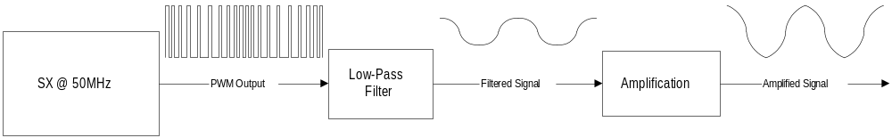The Hardware
This is a block diagram of the analog circuitry on the output of the SX. This can be as simple as an RC low-pass filter.
See the source code, or the bell202 modem document, for the pin definitions and schematic.

